Chapter 4, Problem 46.

Using Fig. 4.113, design a problem to help other students better understand Norton equivalent circuits.
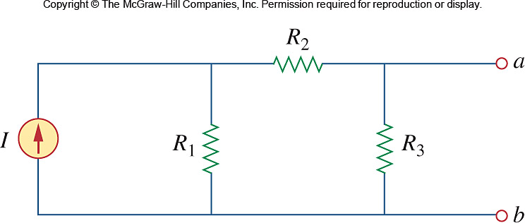

Figure 4.113
For Prob. 4.46.

